**IN4MATX 131 Human Computer Interaction (Assignment #3)**

Discussion 6 - Team 6

Group Members:

* Joseph Alvizo: Scribe
* Alonso De La Torre: Tester
* Matthew Morales: Facilitator
* Jason Tam: Scribe

**Developing Inputs:**

* User: Fabricated/diluted persona developed by the testers.
  + Assumptions: Target user is a middle aged American male who is also handicapped, possesses a moderate level of tech literacy, and does not travel frequently
* Task: Successfully book a reservation at a hotel (per the user’s preference) in Manhattan, New York for the Fourth of July weekend (the 3rd through the 5th).
* Interface: The interface we have chosen is: <https://www.expedia.com> (a hotel, flight, car rental, travel booking website).
* Action Sequence: A more general sequence of actions will be detailed below with accompanying screenshots, in this section we outline a more specific set of actions that were used as guidelines during the testing process. Within this more specific set of tasks we provide the overarching goal, as well as several lower-level subgoals that became the temporary focus throughout the process.
  + Overarching goal: Book a hotel in Manhattan, New York for the Fourth of July weekend (the 3rd through the 5th) for two adults. The hotel must be handicap accessible.
  + Sub-goal: Describe Trip Details
    - Identify the appropriate functionality that would allow one to set the destination location, check-in date, check-out day, and guest selection. (Identify filters if applicable).
  + Sub-goal: Apply Accessibility Filter
    - Identify and utilize accessibility specification filters, and ensure the room to be booked is handicap accessible.
  + Sub-goal: Hotel Selection
    - Once filters have been applied, make a selection from the appropriate list of hotels displayed by the site.
  + Sub-goal: Hotel Reservation
    - Identify and utilize appropriate functionality allowing one to reserve a preferred hotel.
  + Sub-goal: Payment Preference
    - (As part of the specific path we chose) Once prompted, identify and select the preferred approach to payment.
  + Sub-goal: Provide Information
    - Provide all necessary information required to successfully book the preferred hotel (that adequately fulfills the disability condition requirements).
  + Sub-goal: Successfully Complete Hotel Booking and Confirmation
    - Identify current state of overarching goal and reflect on whether one may or may not be aware of system state in terms of completion.

**Action Sequence:**

**1) Expedia Home Page**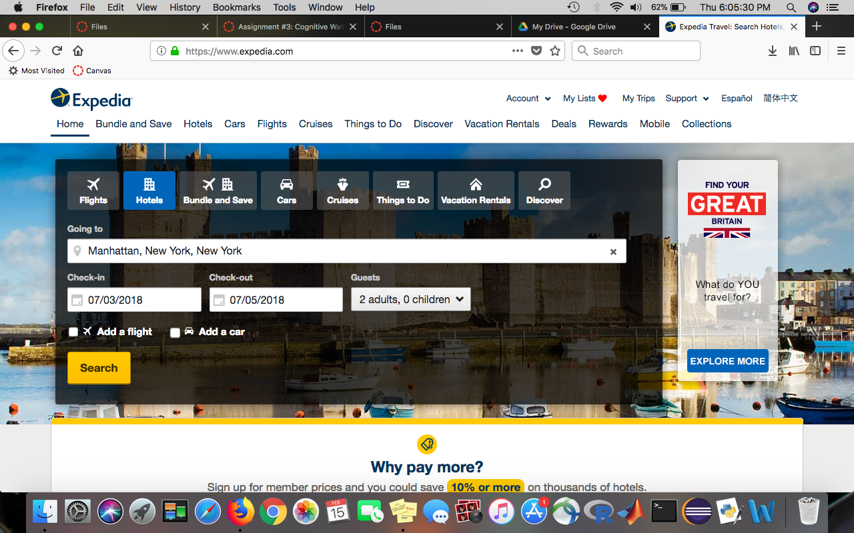

At home page, the tester’s goal was was to discovery the necessary functionality that would allow them to search a for the specific location and times they were assigned. By finding these functionalities the tester should be able to effectively declare their inputs: destination, check-in/out dates, and number of guests. The tester noticed the different tabs on top for all the different possible services, and selected “Hotels”. Next, he quickly found the search bar and input the correct details. By attempting to search hotel listings, he was clearly on the right path. The user can easily enter the information since the search boxes are in the direct center of the window, so they are most likely to be seen first by a user. Thus, all necessary actions are obviously available in the interface. One can assume inputting information will search for whichever service specified in the tabs above, because the distinct yellow “Search” button beneath the search bars. Users do not necessarily get feedback and cannot undo the search, because searching takes them to a different webpage (as shown in the next step); so to undo, the user would just revert to the previous page or refresh the current page. To circumvent this process and promote more user friendly error recovery, we suggested a clear search query functionality. This would provide the user with a server side intent to easily reverse mistaken actions.

**2) Expedia Search Results Page**

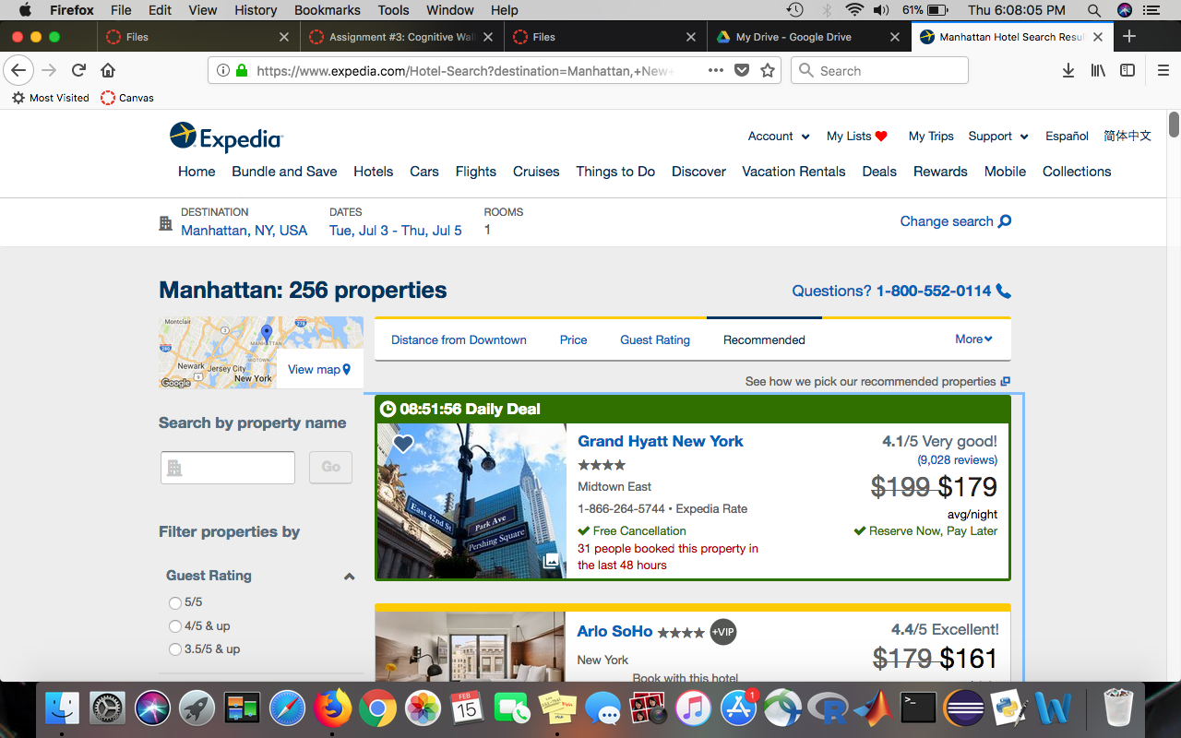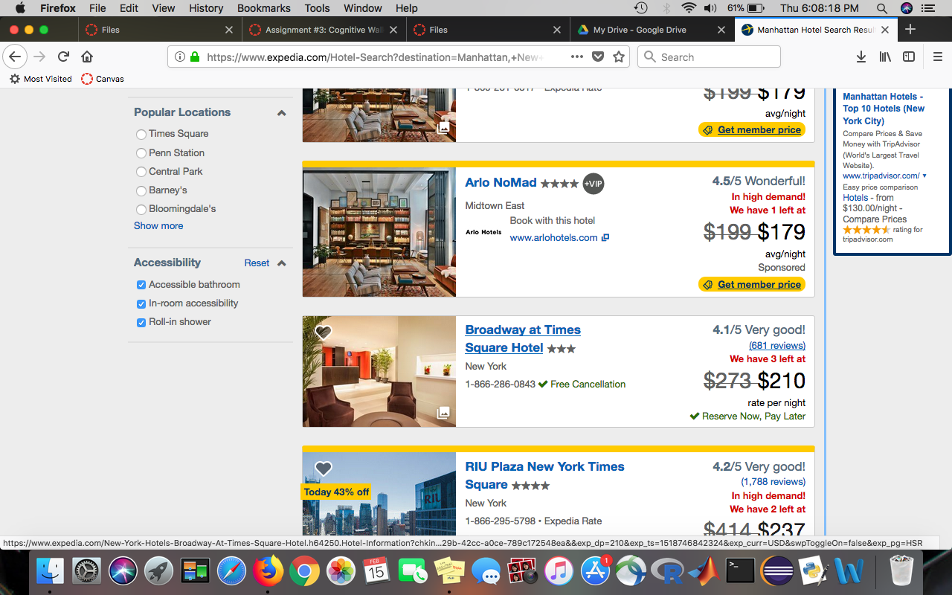Both pictures above display the search results of the input from last step. One difference to note, though, are the different properties on the left side of the screen that the user can filter through. At this screen, the user’s goal is to look through the hotel options and find one of their preference that is wheelchair accessible. At first glance, it was not obvious that all necessary actions needed to complete the goal were present because it took the user a while to find the Accessibility option on the left-hand side. This was due to the fact that the Accessibility options were located towards the bottom of the screen, rather than at the top with similar filtering options. Given most customers and/or users may just look at the first few options, this design may prove difficult to identify necessary options for impatient users. Furthermore, the Accessibility options were vague for the tester, as he stated that he had to google what the different accessibility options were. Everything else, however, was easy to identify that it will do what the user wants. This screen provided excellent feedback, as the tester pointed out, when the user further specified their search. A blue pop-up window appeared that stated “Updating Info”, and then a new list of hotels showed up. Actions and filters can easily be reversed by selecting the same filtering options. The website clearly indicates that a filter has been applied; a check mark will appear when initiated, and will cease to be present when the filter is disabled. Once a hotel choice is made the user is redirected to the next page. The tester chose the Arlo NoMad, so he was redirected to their webpage.

**3 & 4) Hotel Page & Payment Options Screen (Respectively)**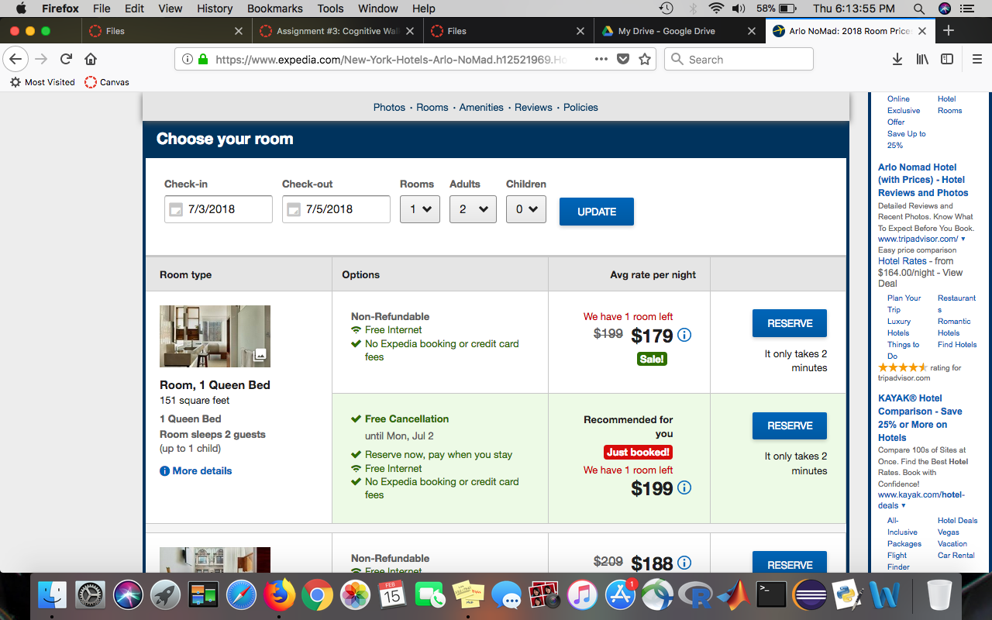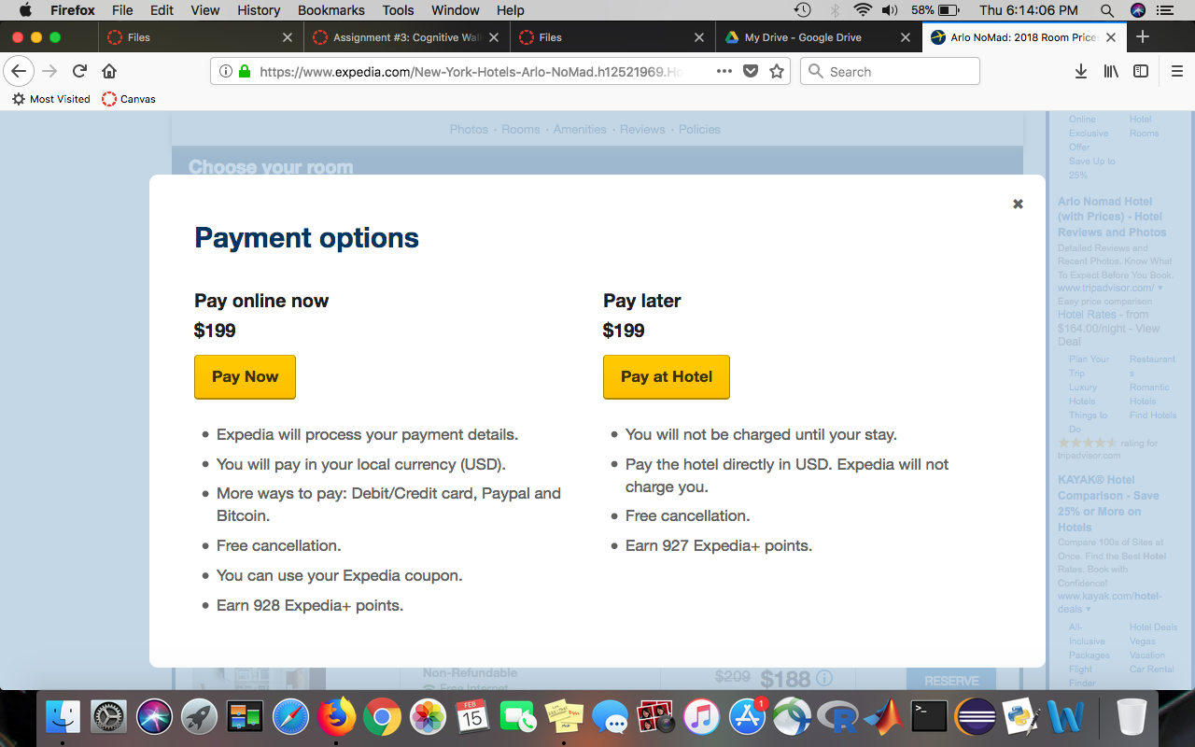

Once a hotel is selected, the user is actually taken to a new tab, and their previous Expedia page is saved. Here the goal is to make a selection to reserve a particular room of the user’s choosing to then be able to pay for the reservation. In order to make a selection the user must be able to compare the various types of rooms and their corresponding amenities. If there was a mistake in a previous step (for example: entering the wrong date, or needing to change the date), the user can easily rectify this by updating their search query. Atop the page sits drop down boxes and check-in/out dates that match previously declared inputs. The page also displays a large list of available rooms. There is a large, noticeable, blue “Reserve” button that makes the necessary actions obviously available. Once recognizing this button, it should be almost impossible for the label of the action to not match a user’s goal, unless of course the button isn’t programmed correctly. When the users presses the “Reserve” button, a pop-up window (shown in step 4) displays payment options that makes users choose between 2 options before continuing. This screen gives good feedback to the user, but also makes it easy for the user to undo the selection in case it was accidental or if the user simply does not want to reserve that particular room; the user can accomplish this by clicking on the black “x” in the top right corner of the “Payment Options” tab. It is designed to promote consistency, given most windows possess a closing option in this position. After the user has chosen their room to reserve, the “Payment Options” screen will pop up. Their next step is to choose if they want to pay online or at the hotel. Here it is clear that the goal of choosing the room was successful, and the large, yellow buttons are good signifiers for the necessary actions to continue to the payment/information page. The user should recognize each button will do what they intent, as they are both labeled correctly in their respective column. The user’s feedback is their redirection to another webpage which asks for their payment information.

**5) User Information Page**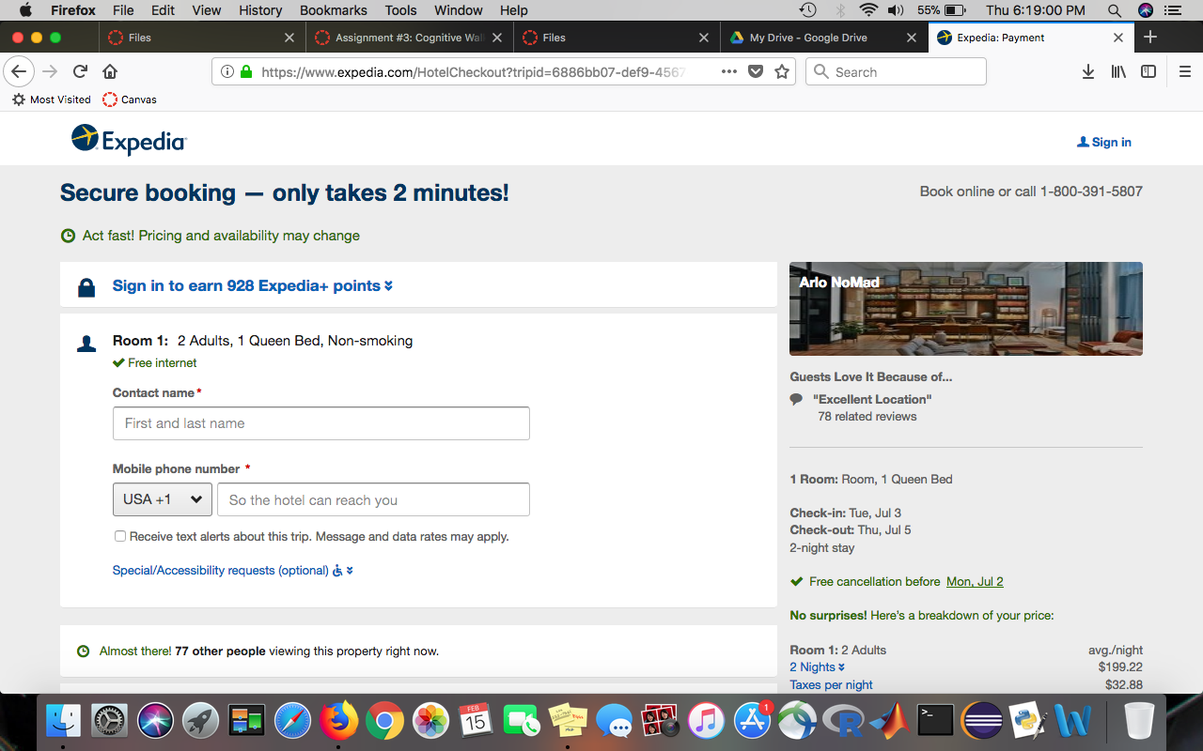

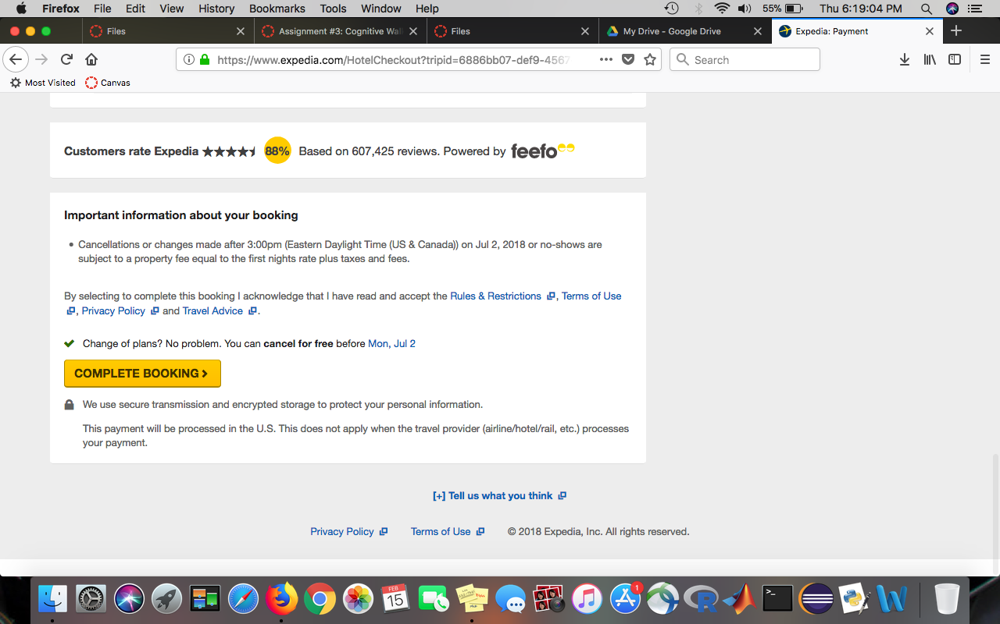

Depending on which input the user chose, they are redirected to a new screen to fill out required information tabs. In the screenshot above, the tester chose to pay the full amount online and was redirected to this new page. On this page, the user’s goal is to fill out all the required fields in order to move on and finally complete their booking. The empty text boxes, along with their titles next to a red asterisk, clearly signify the necessary actions needed in order to complete their goal. Along with these necessary actions, the user is also required to create an account with the site in order to have control over their hotel bookings; all the good signifiers from before are used here as well to guide the user for their goal of creating an account. Account creation is a peripheral goal that may vary based on the selected hotel. Expedia does a fairly decent job at integrating the necessary hotel requirement within its own process, by providing opportunities to stay on the current page and condensing objective completion. Once the user has taken all the necessary actions, there is a big, yellow button with the words “complete booking“ at the bottom of the page, placed there as a good signifier to the user that they have completed their goal. When the user clicks this button, their feedback will be the next page they’re redirected to with all the confirmation information about their hotel booking.

**6) Confirmation Page (Example Screenshot Used)**

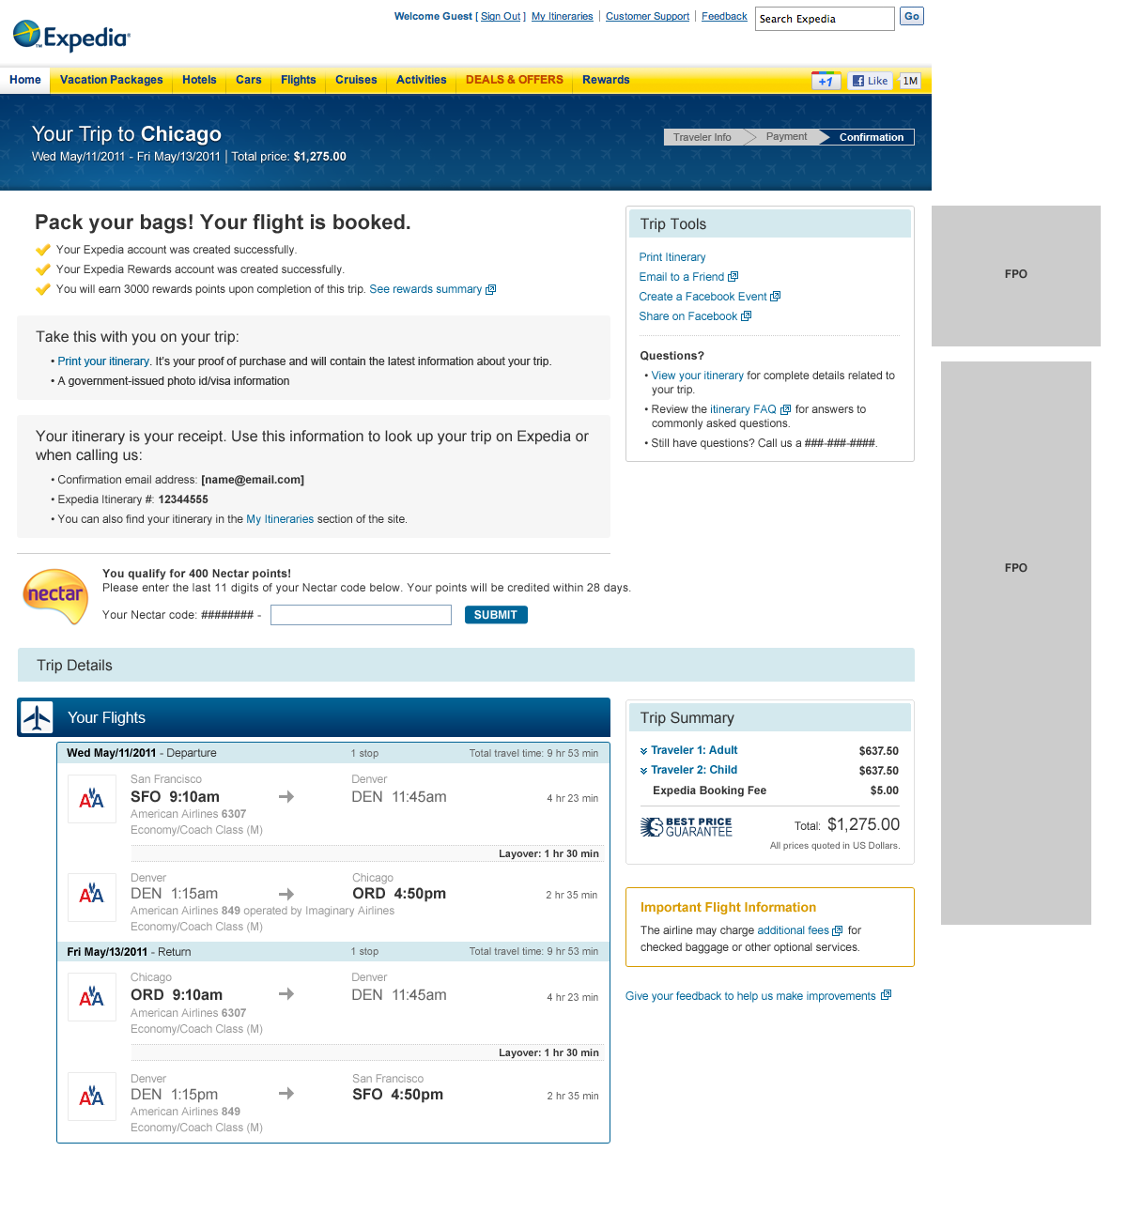

When the user reaches this webpage, it is assumed they have fully completed booking their hotel. The customer must be able to discern when the process is complete, else they may spend unnecessary time trying to discover features that will successfully lead them to the next step. Assuming hotel location, date, and other options are correct, the user has successfully finished. Though this is an example screenshot, we expect it to be relatively consistent with all bookings. At first glance the last page distinctly shows high contrast (yellow on white) check marks clearly defined at the top of the page, along with large bolded font, and several other notifiers that suggest the user has reached the end of the booking process. Other bolded text shows that the relevant customer and “hotel” information has been sent to the corresponding email address. We assume that because the website holds customer security to such high regards, more sensitive information is omitted. The confirmation page is mostly a wall of text with no other identifiers suggesting that the process must continue, therefore the user has fewer opportunities to attempt to move further in the booking process. Given this is the end of the process, should the user have made any mistakes, they must contact the hotel directly for any other changes. While it is more of a social convention it is not clearly stated within the confirmation page and therefore may confuse newer users who are less tech literate.

**Report:**

At each stage, the system was relatively clear in giving feedback to the user and moving them along to the next step. The Expedia webpage in Step 1 which contains the search bar dedicates half of the screen to display search functionality. It is the best and most simple example of signifiers. In comparison however, the last step of the action sequence may be confusing to some users as they may not be aware to wait for a confirmation email. While the confirmation page does fairly well to indicate it is the end of the process -by providing large, bolded text, and high contrast signifiers- the rest of the text is small and superfluous. The email confirmation is nested within the less significant information and can easily be overlooked. Perhaps by grouping more relevant details the system can be more user friendly and organized. Furthermore, when a user has selected a specific hotel during Step 3 and sees a list of available rooms, they have to select “More details” on the left-hand side to see the accessibility options they selected during the previous step. Because that text is small in comparison to the rest of the screen, users may not see it and therefore will not see the accessibility options, possibly confusing them. Also, as previously discussed, the accessibility filter modifiers are located near the bottom of the page and may not be visible to impatient users of the system. To fix this and prevent possible confusion and frustration, one could simply replace the “More Details” button and consense the information and details the user selected for their room with the rest of the room’s description. We came to a consensus that Expedia can do a better job of doing providing filter options in a more visible manner for users. In Step 2 when the user has inputted their request for hotels and is displayed with results, the filter options are on the left side but not all filter options are visible right away. In this case, the task required a hotel room with accessibility requests, yet it was difficult for the tester to find that filter right away; he had to do some work before it was found. My suggestion would be for Expedia to condense the filter options into main categories that are displayed right away for the users, and then subcategorize those main categories into more options after the user clicks which filter they want to apply.